

**THE**

**GREEN**

**C**

**O**

**N**

**C**

**E**

**R**

**N**

WHY GREEN CONCERN

The ‘GREEN CONCERN’ is an E-MAGAZINE which stresses the importance of sustaining our planet earth for future generations.

The magazine has approached the concept of sustaining planet earth in four ways.

1. Evidences for the high stress on mother earth.
2. Causes for stress on earth
3. Effects due to the stresses on earth.
4. Solutions

**EVIDENCES**

1. ATMOSPHERIC CARBON LEVEL CHANGE

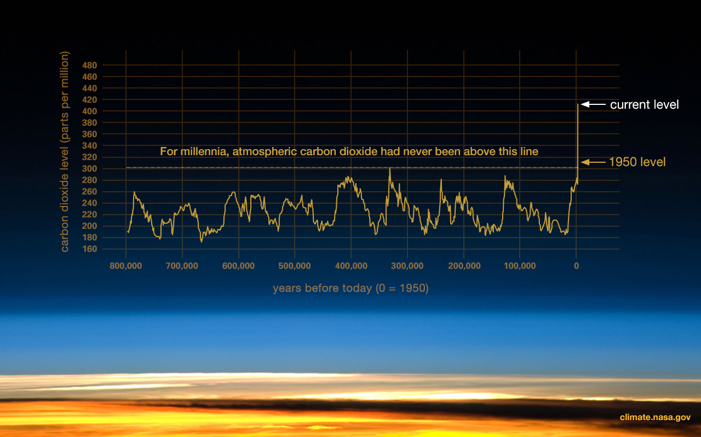

1. GLOBAL TEMPERATURE RISE
2. SHRINKING ICE SHEETS

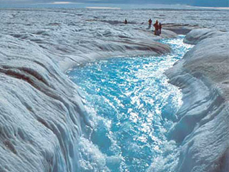

1. GLACIAL RETREAT

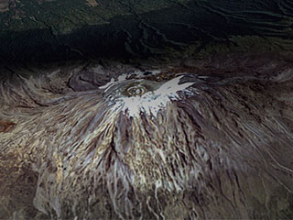

1. DECREASED SNOW COVER



1. SEA LEVEL RISE

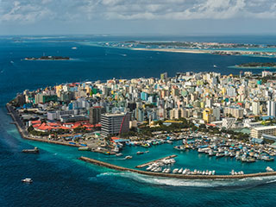

**CAUSES**

1. GREEN HOUSE EFFECT



1. POLLUTION

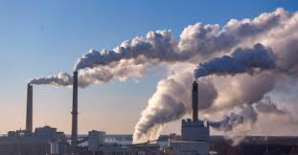



1. DEFFORESTATION

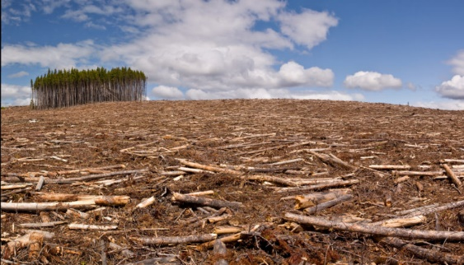

**EFFECTS**

1. GLOBAL WARMING

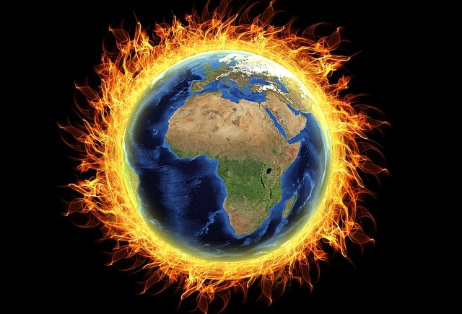

1. DRAUGHTS AND HEAT WAVES

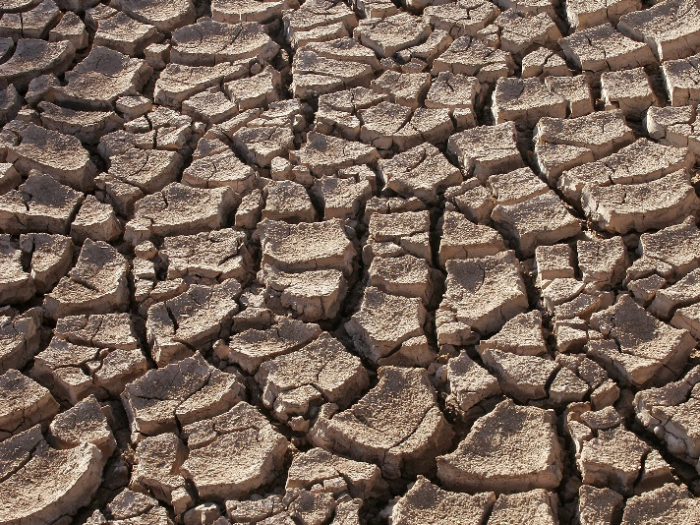

1. INCREASED FREQUENCY AND INTENSITY OF HURRICANE

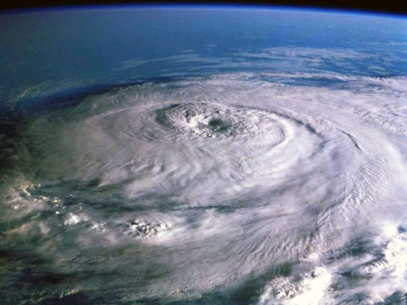

**SOLUTIONS**

1. SPREADING AWARENESS



1. USING RENEWABLE RESOURCES

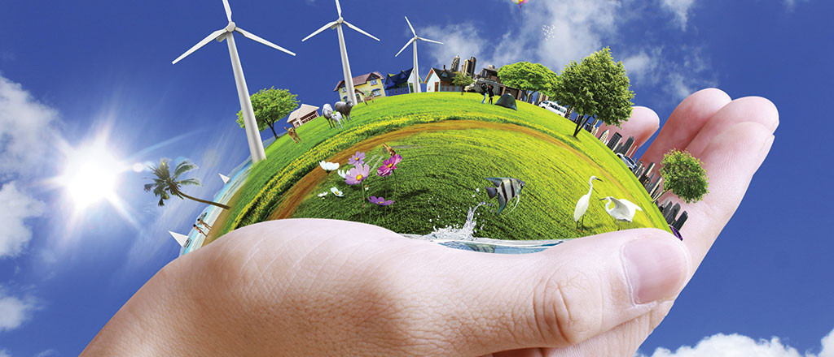

1. PROMOTE AFFORESTATION

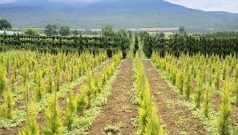

1. ENHANCE SUSTAINABLE DEVELOPMENT

